School of Electronics and Computer Science

Faculty of Physical and Applied Sciences

University of Southampton

Saber HAMIDI

26th April 2016



**The Use of Social Networks for Marketing**

Figure Graphical representation of social media marketing <http://www.getsticky.com.au/3-reasons-to-hire-a-specialist-for-your-social-media-marketing/>

Project supervisor: Professor Leslie Carr

A project progress report submitted for the award of

MComp Information Technology in Organisation

# Abstract

Social media, online presence, and e-commerce have changed the way restaurants businesses do marketing, and promote their brands. However due to no budget to invest in technology, and lack of expertise, small local restaurants and takeaway shops are left behind when it comes to online presence. This project aims to implement a social media-marketing platform that enables small local restaurants to grow a network of customers online, and promote their brands using that network. This progress report focused on social media marketing background research, which includes, existing solutions, and the project aim & objectives. It continues to the requirements analyses, and the project plan for implementing the platform. The plan includes the system Gantt chart and the system architecture design. Plan for the remaining work includes implementation of the system, testing and deployment.

# Contents

Abstract 2

Contents 3

1. Introduction 4

1.1 Problem 4

1.2 The Project Goals 4

1.3 Scope 4

1.4 The Project Changes 4

2. Background Research 5

2.1 Existing Attempts and Solutions 5

2.2 Related Work 7

2.3 The Project Aims 7

2.4 The Project Objectives 7

3. The Requirements Gathering 9

3.1 Functional and Non-Functional Requirements 9

4. The Project Plan 10

4.1 Initial Design 10

4.1.1 Campaign Walkthrough 11

4.1.2 Major Platform Functions 11

4.2 Gantt Chart 12

5. Summery of Work to Date 13

6. Plan for the Remaining Work 14

7. References 15

8. Appendices 17

# 1. Introduction

## 1.1 Problem

I have already built a website for a restaurant called “British Dining”. It allows customers to order online, and my plan for the future is to develop the same website for hundreds of other restaurants around the UK.

The restaurants have no means of marketing and distributing their food advertisement in a technological way. TV adverts and spreading leaflets fliers are very costly, and plus specific customers can’t be targeted this way.

## 1.2 The Project Goals

My agreed project is based on creating a smart system that uses social media ID (#TwitterID) of every single user that has made an order to the restaurant, to advertise to them the relevant types of food that they might like, based on analysing their social network activities. This smart system will enable the restaurants to target specific customers for specific food advertisements and marketing, using social networks.

Building a system like this is hugely relies on accessing social media libraries in order to fetch users posts and tweets. Therefore the problem of privacy may get in the way, however it will be dealt with in the users agreement.

## 1.3 Scope

The user of this system will be the restaurant and its consumers. This project is only focused on the marketing system of the restaurants businesses. Therefore it includes advertising through social media, launching social media campaigns, and to grow the marketing network. The scope of this project does **not** cover online ordering facility, or building website for the restaurants and takeaway shops. Payment processing is also considered to be **outside** the scope of this project.

## 1.4 The Project Changes

The main project aim agreed to be personalised promotion using social media, at first. However after having finished the background research, it has been agreed with the supervisor that the project should also include two types of social media marketing campaigns too. It was agreed because, as a result of background research, social media campaigns proved to be as successful way of social media marketing for small businesses.

# 2. Background Research

Despite the huge attention of restaurants businesses on engaging with their customers using social media, a lot of them have no online presence. Therefore they are left behind, when it comes to smart marketing, where use of mobile phones and grow of social networks have changed the way people and businesses interact [11]. It is reported that still 65% of the restaurants are not online, which means they not taking advantage of e-commerce, neither they make use of social media marketing [1]. Most of them are small, local takeaway shops, with no budget to invest in technology or in technological marketing. This has caused them to consequently miss the opportunity that social marketing brings to boost their sales [1]. This project will enable all of those restaurants businesses that are fallen behind, to catch up with today’s modern technological way of marketing and engaging with the customers in a new way.

On the other hand almost all of the big businesses in fast food industry like Domino’s Pizza, Pizza Hut, Papa Johns etc. have already started e-commerce from as early as 1994 [12]. In addition they also take advantage of social media marketing. Since technology is getting more advance every year, and mass distribution of smartphones and use of Internet is changing the way we live and do things, the big restaurants and fast food businesses have understood the importance of investing in e-commerce, as well as making use of social media marketing to run their businesses parallel with todays technology [13]. Domino’s Pizza has reported that 75% of their sales in 2015 were online, and more than half of these sales have come through their mobile app [2].

## 2.1 Existing Attempts and Solutions

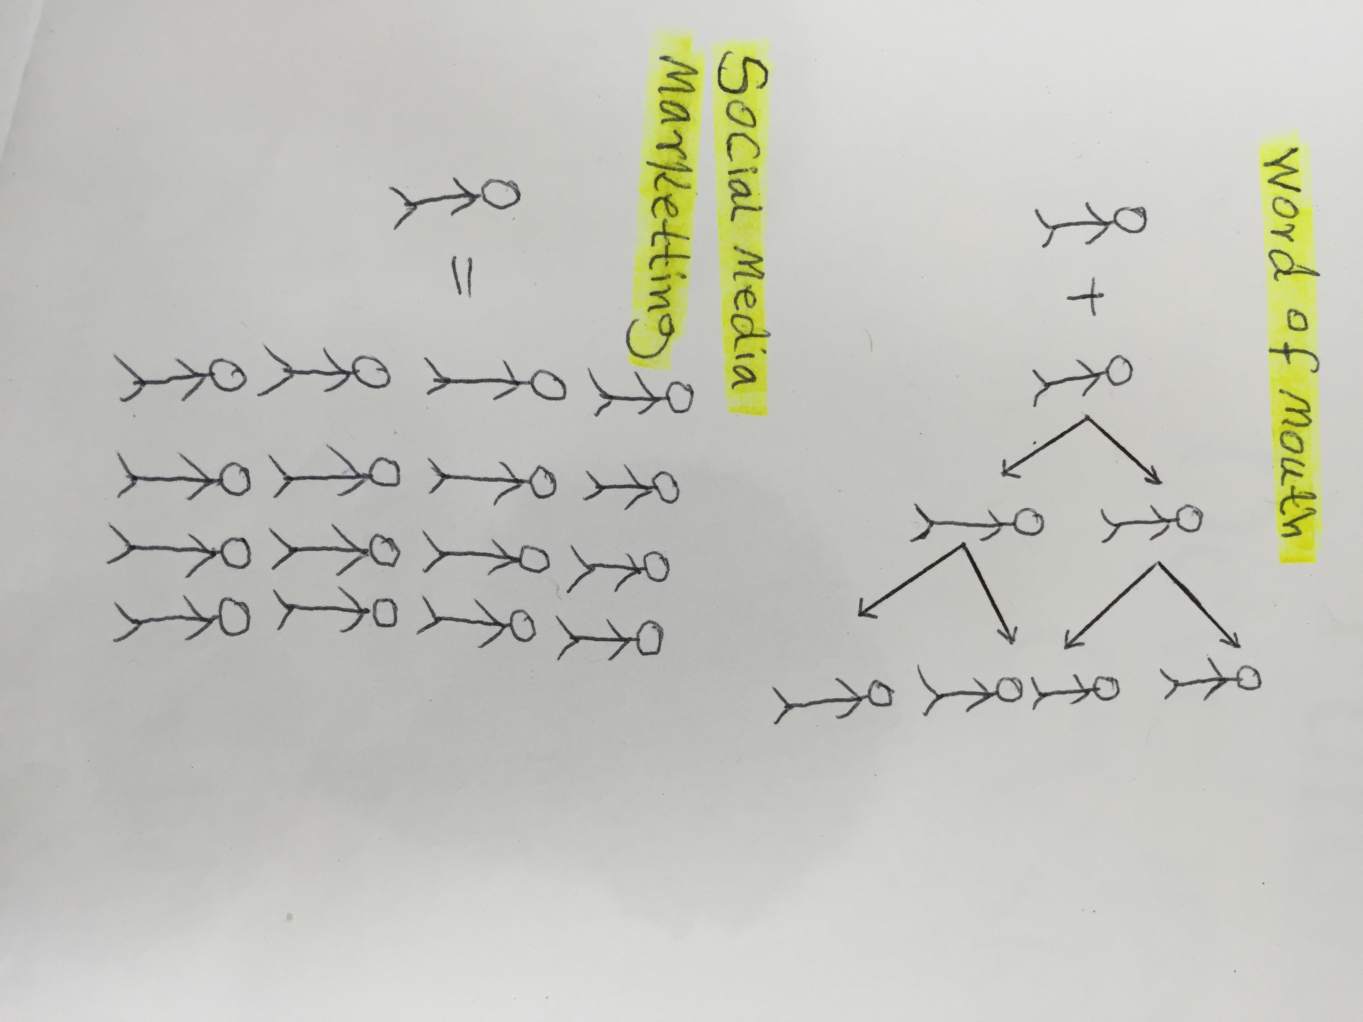Having researched the use of social media for marketing prospective, it is found that already businesses are taking advantage of the mass amount of users social media have every minute. Fast food businesses and restaurants trying their bests to stay ahead of the game, and attract as many customers as possible, using social media marketing [14]. They have even tried to target relevant customers with the use of social media, because it has been known the most popular activity on the web [3]. On the other hand **some third party aggregators such as Just-eat and Hungryhouse are also already dominant in terms of web presence, ordering faculties, and payment processing for the restaurants [15]. However they haven’t touched the field of marketing to enable small brands to promote themselves.**

On April 2014 Qdoba (Mexican restaurant chain) opened a social media campaign that enabled Qdoba Queso sauce eaters to vote for their favorite Queso sauce [4]. A total of more than 30,000 voters participated in the campaign. **Figure 3** shows visualized information about the campaign result by Qdoba.

Figure 2 Word of mouth VS social media marketing

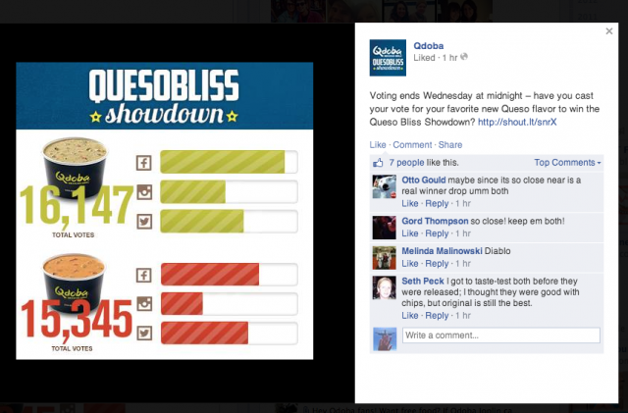

Figure 3 Qdoba Queso compaign screen shot

For Qdoba restaurant this is an official way of connecting customers with their products, and it means that, their voice gets heard by thousands of people out there. This has had a positive effect on their sales and building their brand image [10]. In addition to that, by analysing the customer’s tweets and comments the restaurant can learn a lot about their customer’s desires, and they can tailor their promotions according to their needs, which will result in huge success in the long run.

On Jun 2015 Havana Restaurant & Bar also held a Giveaway Campaign for the participants to win a free one-hour bar for the winner and nine of his/her friends. The participant were asked to like the restaurant Facebook page and write “Open bar” on their Facebook wall, following them on Twitter and tweeting name of the restaurant, as well as signing up for their emails [5]. Check **appendix 1** for more social media examples.

The two restaurants (Qdoba, Havana) both promoted their campaigns using Wishpond, which is a third party marketing platform, that runs, track, and manage different social media campaigns, not only for the restaurant firms, but also for any other brand [16]. **[Read more about Wishpond on Page 7]**

Qdoba and Havana restaurants social media campaigns are only two examples of how businesses bring awareness about their brands and promotions through Facebook and Twitter. Many restaurants have set up official accounts on social media, having tried different ways of marketing, from campaigns to offering discount for specific group of followers, to engage with customers and learn as much as possible about their expectations.

## 2.2 Related Work

**As the description clarifies, the aim of this project is to develop a smart system that enables restaurant businesses to analyse customers’ activities through social media and subsequently target them for a specific products or promotions. Having researched the closest attempt for targeting relevant customers through social media marketing is done by Wishpond, which is a platform that provides businesses with social media campaigns, and many other marketing tools such as; website popups, online forms, marketing automation, email marketing, retargeting ads and marketing analytics [16]. They uses the power of social media to drive traffic to the advertiser’s website. It uses Target Ads feature of Facebook to target customers in a specific geographical area [6]. However unlike the aim of this project Wishpond haven’t gone that far to analyse customer’s social media activity for personalised promotions targeting.**

## **2.3 The Project Aims**

**Some high value fast food companies with big budgets, e.g. Domino’s and Pizza-Hut are already dominant in terms of having established their own online-presence, e-commerce, and marketing. This project aims to build a social media-marketing platform that is focused on small restaurants and takeaway shops who have no investment in technology. This system will brings the marketing functions of big brands to the small restaurants and fast food businesses, using social media. It will advance the retails system of small businesses with small budgets in the fast food sector to take advantages of the same marketing intelligence as Domino’s & Pizza-Hut, which is otherwise far less, affordable for them.**

## **2.4 The Project Objectives**

**The objectives considered in this project are;**

* **Finding the right social media campaigns for small restaurants businesses, with small budget, and hyper local audiences**
* **Creating a platform for the relevant social media campaigns, and personal advertisement**
* **Evaluate the system by running a real campaign as a trial on one of the local restaurants in the town**

Having revised the variety of social media marketing campaigns Wishpond offer to businesses, the restaurants targeted in this project suffer from having no online presence and no social media followers yet. Therefore this project will also focus on two types of social media campaigns that deliver the promoting voice of the restaurant businesses to as many customers as possible, while growing the marketing network at the same time, for sales improvements. This will enhance a big opportunity for the restaurants to introduce themselves and their product to the customers, as well as also learning about their customers’ values and desires [8]. Hence it will result in a constant grow in their monthly sales [8]. According to the restaurants needs, the following types of social media campaigns are chosen for this project.

1. Recommend for Reward
2. Re-tweeting Promotion

Recommend for reward campaign is the idea of sharing a page in social media to be liked or registered for. For every respond the recommender will receive a reward, e.g points to be used as discount on meal order. It is a great persuasive technique to grow brand network and pump the promotion message into that network.

Re-tweeting campaign is also allowing the users to tweet a promotion and ask followers to re-tweet it back, and it goes down to followers of the followers to re-tweet it back. At the end of the campaign anyone who got most re-tweeted will win the prize, e.g a free meal for the winner and four of his/her friends. This campaign is chosen because it is also a really powerful technique to grow a marketing network [7].

In addition to providing social media campaigns, this project aims to provide restaurants with personal advertisement. According to the research no other tools have been ever developed that is smart enough to analyse customers social media activities & interests, and roots the advertisement traffic according to the customers desires. This feature of the system will be used mainly for targeting individual customers to be addressed with promotions that matches their personal eating desires.

# 3. The Requirements Gathering

Since small local restaurants are unable to invest in technology and online presence, like the big brands, I am building a marketing platform that uses social media to enable small firms to improve their branding and sales. The followings are lists of requirements for developing this system.

## 3.1 Functional and Non-Functional Requirements

The requirements are divided into two categories; functional requirements that relates to what the system should do, and non-functional requirement that refers to the system quality [9]. **Table1** bellow illustrates a list of requirements.

Table 1 List of Requirments

|  |  |  |
| --- | --- | --- |
| Category | Description | Priority |
| Functional | Perform analysis on customer’s social media activities, and promote relevant product. | High |
| Functional | Auto promotions distribution to hundreds of customers by email | Medium |
| Functional | Set a Recommend for Reward social media campaign | High |
| Functional | Set a Re-tweeting Promotion campaign | High |
| Functional | Analyse and calculate the campaign result | High |
| Functional | Calculate the prize | High |
| Functional | View statistical information about the current state of a campaign | High |
| Functional | Users should be able to unsubscribe from the promotion emails | Medium |
| Non-functional | Providing usable and accessible interface | High |
| Non-functional | Assuring users about their privacy and data protection | High |
| Non-functional | Easy and clear instruction to participating in the campaign | Medium |

# 4. The Project Plan

Prior to the project development, in this section of the report all the steps and methodology for implementation of the system are explained.

## 4.1 Initial Design

**Figure 4** bellow illustrates the core architecture functionality design of the system, by using Christmas campaign as an example. It will explain how the system interconnected and how will it function.

## 4.1.1 Campaign Walkthrough

Figure 4 The System Architecture Design

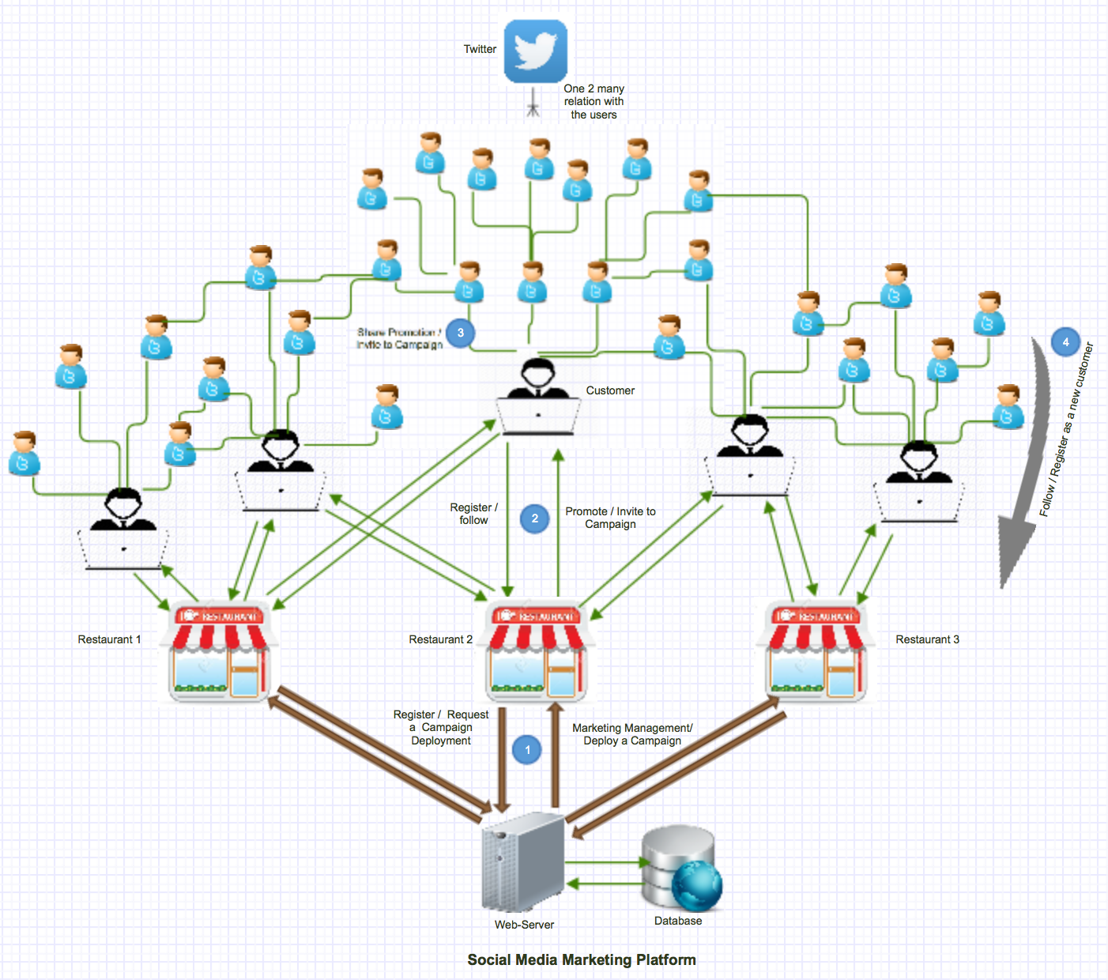

Assuming that at least one restaurant is registered with the system, and a few customers are following or registered within the restaurant website. The Christmas campaign is a Re-tweeting campaign that is either requested by the restaurant to be created or recommended by marketing management team to the restaurant and they have to confirm that, by providing some of the parameters needed to create the campaign, such as; start date and end date, the campaign hashtag, a set of offers to be promoted in the campaign, and the prizes for the winners. For this illustrative campaign these are

Restaurant: British Dining

Campaign Type: Retweet Competition (winner is person who gets most re-tweets for the restaurant)

Campaign Title: Christmas Campaign

Start: 1/12/2015, End: 25/12/2015

Hashtag: #ChristmasSurprise

Offers: 30% off Christmas menu for students

Prize: Free Christmas dinner for winner

After the parameters are set, the campaign gets launched to the customers as illustrated in **step one** of the design, the customers will share the campaign with their friends and family, as shown in **step three** of the design. As the campaign gets shared and re-tweeted by more and more people the marketing management team will monitor and analyse its performance, and the information will be shared with the relevant restaurant for which the campaign is held. After the deadline the marketing system will summarise the result and calculate the winners. The winners will be notified by email and it will be shared among other users in the network to motivate them for participating in the next campaign. The users who responded to the campaign will now know about the particular restaurant and they might visit the restaurant and register as a new customer. Hence it will result in network growth.

## 4.1.2 Major Platform Functions

*Restaurant Registration:* store all restaurant details in database; choose standard website template and fill in details; create empty database of restaurant customers.

*Customer Registration:* store all customer details in database including address info, demographic info, payment details, social media ids for Twitter, Facebook etc.

*Campaign Management:* create campaign, edit campaign, start campaign, report on campaign progress, halt campaign.

*Social Media Management:* send message to customers of restaurant, monitor mentions of restaurant, monitor mentions of campaign hashtags.

## 4.2 Gantt Chart

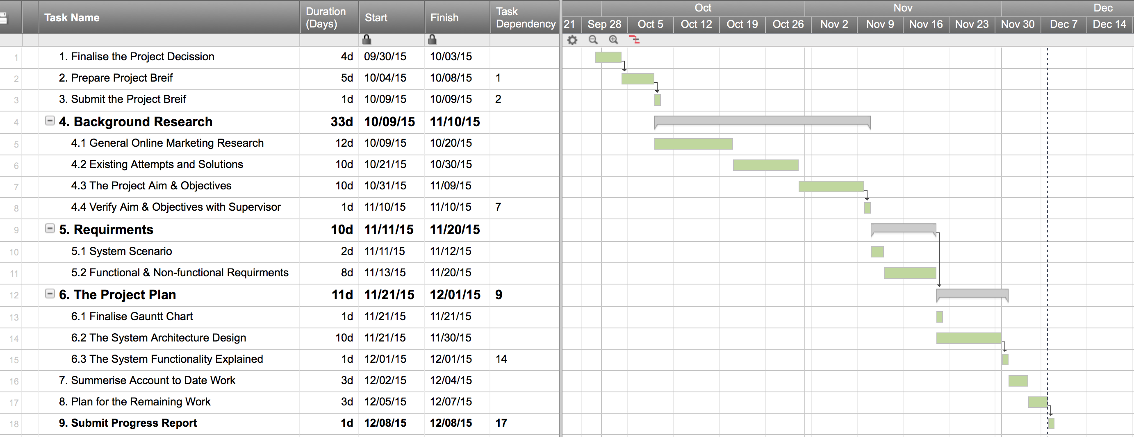**Figure 5** illustrates a schedule of this project. It represents a list of tasks with its duration in days, and its ‘start date’ & ‘end date’, over the first and second semester. Some tasks have dependency with another task, and it is represented under the column “Task Dependency”. e.g it is compulsory to finish the requirement before starting the project plan. In the right hand side of the chart, each task is also represented graphically, and it shows any dependencies between tasks, with a drop down arrow.

08 Dec

The Gantt chart continues….

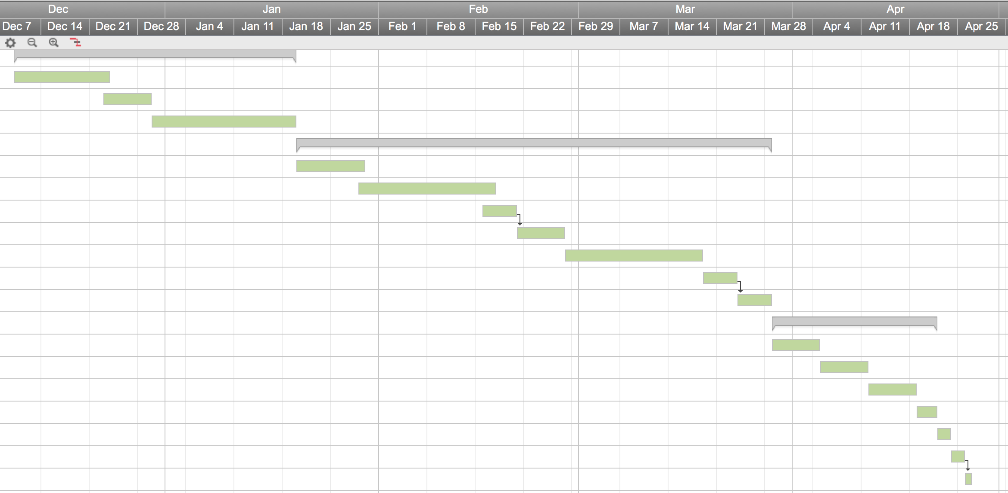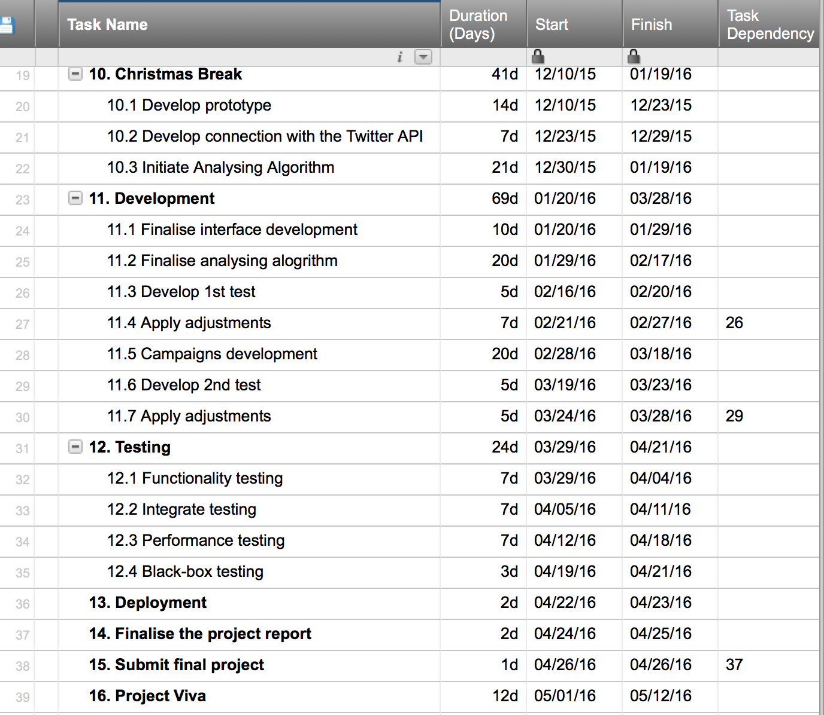

Figure 5 The project Gantt Chart

# 5. Summary of Work to Date

The project started first by agreeing the project brief with the supervisor as shown to be the first task in the (**Figure 5 Gantt chart**). After submitting the brief, the first part of this report focuses on the background research about the social media marketing and e-commerce in general. The existing solutions, that provides similar services to this project discussed in this section too. The aims and objectives of the project are justified in respect to the awareness of the current online marketing and existing solutions.

The report continues analysing the requirements, prioritising and categorising them into functional and non-functional requirements. After requirement analysis, the project plan starts by designing the architecture design of the system. It illustrates how the system will function and how inter-communications take place between the stockholders. This has been explained by giving Christmas campaign as an example, and a list of major functions.

This progress report gets finalised by including the Gantt chart used to manage and keep track of the list of tasks subtask for the progress of this project.

# 6. Plan for the Remaining Work

Before the end of the first semester the goal is to prepare a prototype model of the system. The system interface design will be first drawn as wireframe, and it will be used to develop the system interface. The prototype will establish a basic connection to the Twitter API and tries to extract relevant information, to help the system target different users with personal promotions. In the start of second semester the main development will begin. The iteration of development will be undertaken by the spiral methodology, and relevant adjustment will be made after each cycle of iteration. The complete development may take 6-8 weeks (4-5 iteration cycle). The project progress will get discussed weekly with the supervisor.

Following the development completion the testing and evaluation phase will take place. This will include black box testing, functionality testing, performance testing, as well as unit testing. The testing will include running a promotion campaign for one of the local restaurants and evaluate the process and the out come of it, therefore in this process support and participation of a local restaurant is needed. The whole testing process will approximately take up to four weeks.

# 7. References

[1] B. S. Austin and S. J. Melly, ‘Clustering of fast-food restaurants around schools: A novel application of spatial statistics to the study of food environments’, *Am J Public Health*, vol. 95, no. 9, pp. 1575–1581, Sep. 2013.

[2] BBC, ‘Domino’s pizza sales boosted by mobile app’, *BBC Business*, BBC News, 14-Oct-2015.

[3] G. Liu and Y. Fu, ‘Discovering temporal Retweeting patterns for social media marketing campaigns’, vol. 4, pp. 905–910, Dec. 2014.

[4] A. Zechman and H. Young, ‘The 30 most brilliant social media campaigns of 2014 (so far) - Salesforce marketing cloud Blog’, *Cross-Channel*. Salesforce Marketing Cloud Blog, 28-Apr-2014.

[5] M. Hensel, ‘5 social media contests that bring traffic to restaurants’, *Facebook for Businesses*. Social Media Content Creation & Lead Generation by Branding Personality, 10-Jan-2012.

[6] K. Bunskoek, ‘Social media marketing for restaurants’, *Wishpond*, 07-Aug-2013.

[7] N. Michaelidou, N. T. Siamagka, and G. Christodoulides, ‘Usage, barriers and measurement of social media marketing: An exploratory investigation of small and medium B2B brands’, *Industrial Marketing Management*, vol. 40, no. 7, pp. 1153–1159, Oct. 2011.

[8] S.-C. Fan and Y.-L. Lai, "A study on e-commerce applying in Taiwan’s restaurant franchise," pp. 324–329, Aug. 2010.

[9] X. Lian and L. Zhang, "Optimized feature selection towards functional and non-functional requirements in software product lines," pp. 191–200, Mar. 2015.

[10] P. Taban, "Social media marketing: Qdoba’s Queso showdown," 2014.

[11] S. Sheikh, "Marketing and Branding for SME’s," pp. 1–46, Apr. 2014.

[12] C. Walsh and PR Newswire, "Pizza Hut Celebrates 20th Anniversary of World’s First Online Purchase," PR Newswire, 2015, pp. 1–2.

[13] Z. Zhang, Q. Ye, R. Law, and Y. Li, "The impact of e-word-of-mouth on the online popularity of restaurants: A comparison of consumer reviews and editor reviews," *International Journal of Hospitality Management*, vol. 29, no. 4, pp. 694–700, Dec. 2010.

[14] I. S. Pantelidis, "Electronic meal experience: A content analysis of online restaurant comments," *Cornell Hospitality Quarterly*, pp. 1–9, Aug. 2010.

[15] M. Grothaus, "Just eat vs. Hungryhouse: What’s the difference AND which is best?," Know Your Mobile, 2015.

[16] B. Bree, "About us," in *Wishpond*, Wishpond. [Online]. Available: https://www.wishpond.com/about-us/. Accessed on: Nov. 5, 2015.

# 8. Appendices

**Appendix 1**

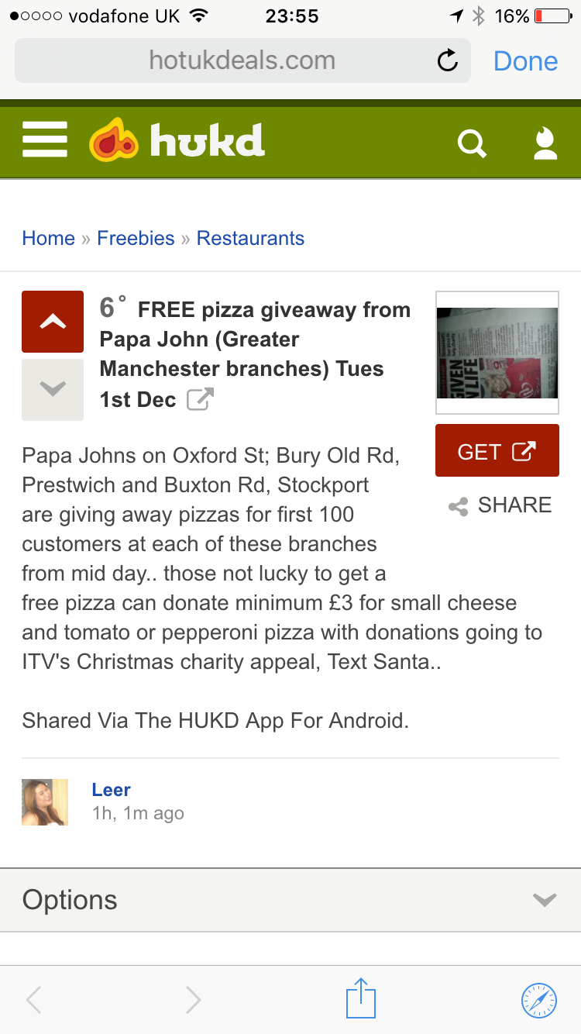

Figure Papa John FREE pizza campaign

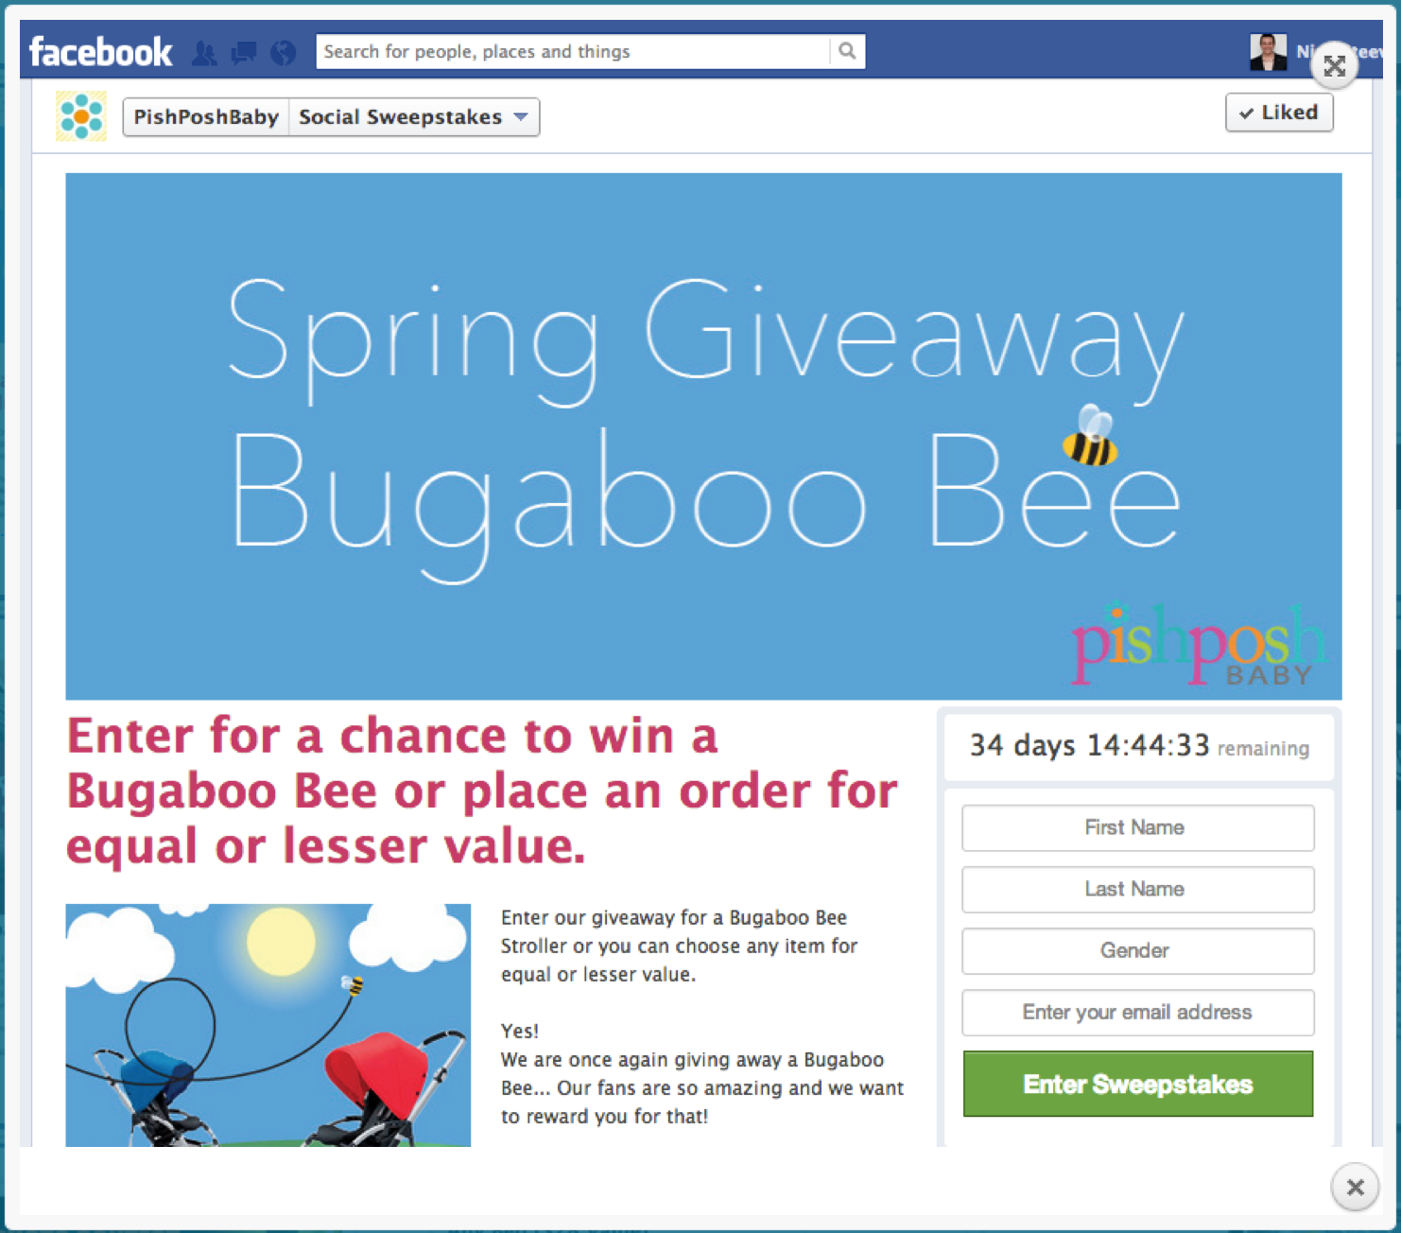

Figure A social media campaign by Pishposh Baby

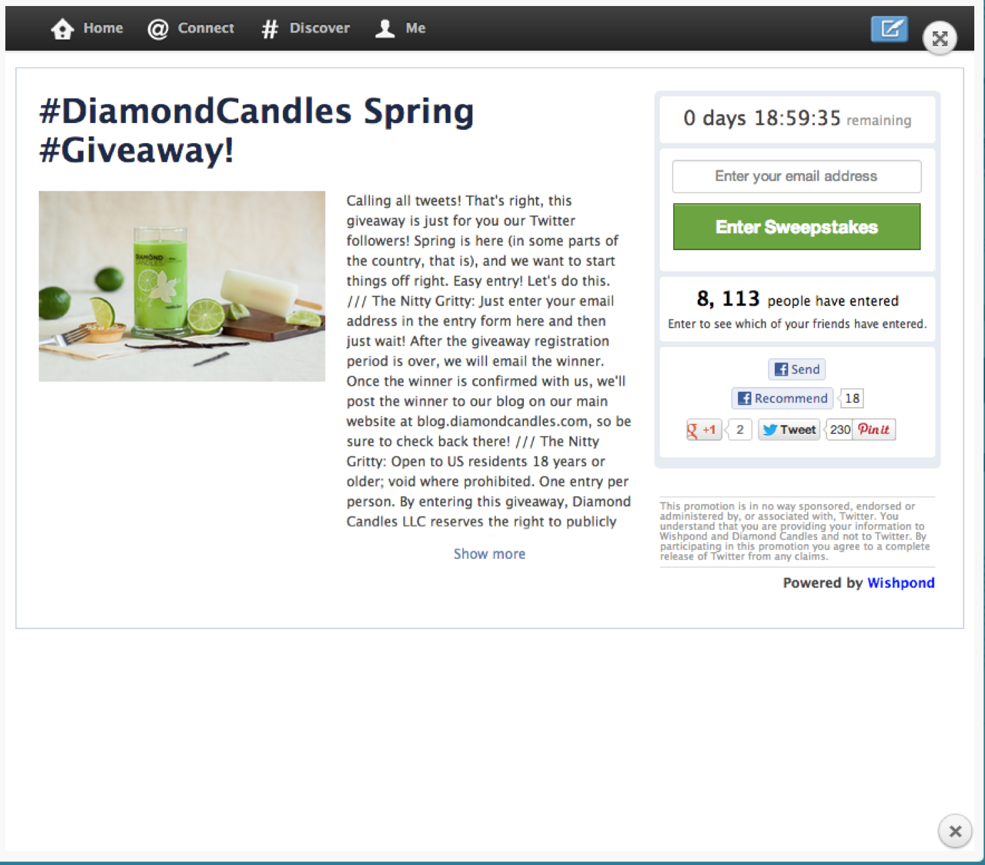

Figure Diamond Candles Spring campaign

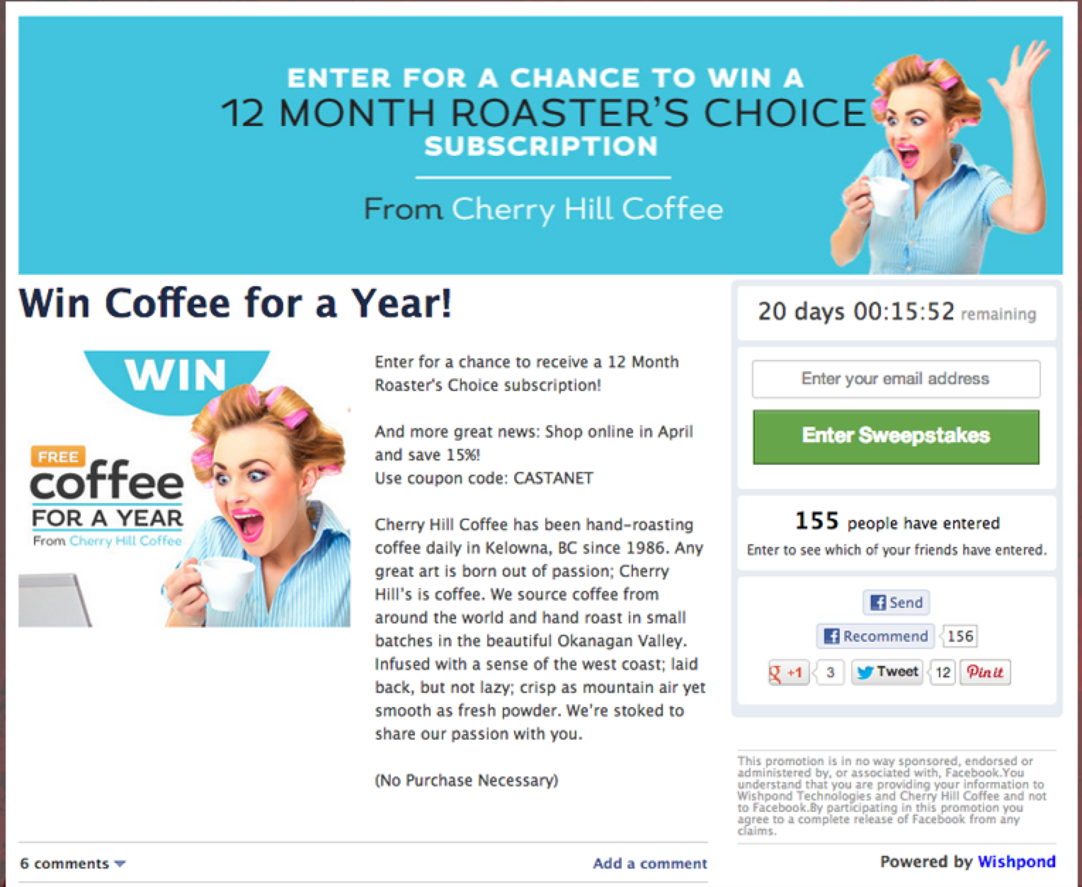

Figure Cherry Hill Caffee campaign